Location:
Ashford Show Ground, 5km North of Ashford on Bonshaw Road. Follow the signs

Camping Facilities:
Free Camping Available
Powered Sites
Hot & Cold Showers

Canteen Facilities:
Full canteen available all weekend
BBQ Friday Night
Breakfast on both mornings
Dinner Saturday Night – 2 course meal
Full Bar Facilities
EFPOS Available

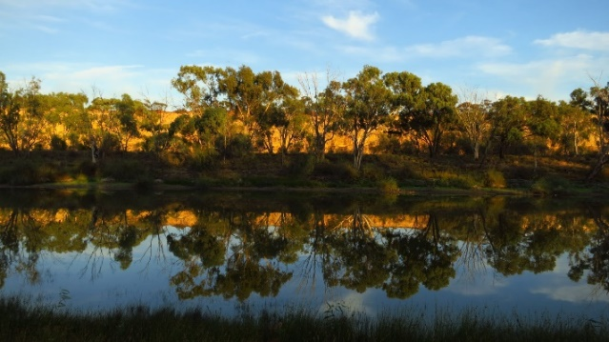

A BIG THANKS TO OUR SPONSORS:

Nutrien Inverell
Derrin Keane Contract Mustering
DBS Ag
Stewarts Grain
Regal Aussie Whites
Colin Say & Co
MLT
Fletcher International
Sapphire Nutrition
Mountain Valley Poll Hereford
Vince Strang Motorcycles
Campbell’s BP Fuel
Mowbray Speckle Parks
McGregor Gourlay
D & R Thompson
K Paul Mechanical
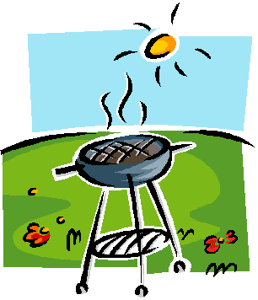

Committee reserves the right to alter program as required
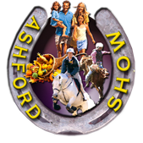

ASHFORD SHOW SOCIETY

SHEEP YARD DOG
&
CATTLE DOG TRIALS

Saturday 4TH & Sunday 5TH
May, 2024

Ashford Showgrounds

7am Start Both Mornings
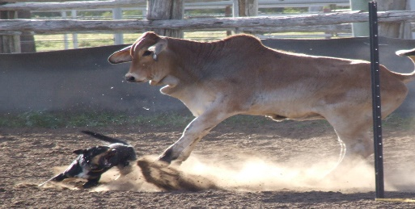
Cattle Dog Program
(North Coast Rules)

All stock have been exposed to working dogs

Saturday, 4th:

- Nutrien Inverell Open Dog Trial
Total Prize:$445 Noms: $20
1st:$200 2nd:$125 3rd:$65
4th:$35 5th: $20
- Derrin Keane Contract Mustering Bush Dog Trial (nom’s on day) (100km Radius)
Total Prize:$100 + prizes Noms: $5
Winner Takes: $100 Cash
- Final of Nutrien Inverell Open Dog Trial (Under Lights)

Sunday, 5th:

- DBS Ag Maiden Dog Trial
Total Prize:$265 Noms: $10
1st:$120 2nd:$75 3rd:$40
4th:$20 5th:$10
- MLT Novice Dog Trial
Total Prize:$345 Noms:$15
1st:$150 2nd:$100 3rd:$50
4th:$30 5th:$15
- Final of Maiden (If numbers & time permits)
- Final of Novice

Maiden & Novice Trials may be run in conjunction depending on nominations.
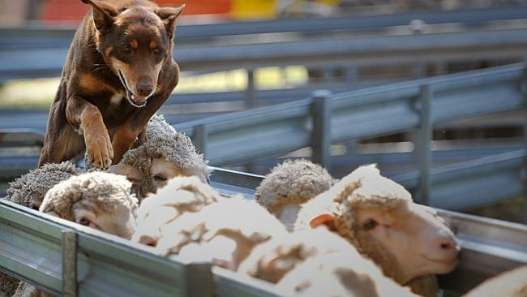
Sheep Yard Dog Program

All stock have been exposed to working dogs

Saturday, 4th:

- Colin Say & Co Maiden Dog Trial
Total Prize:$265 Noms: $10
1st:$120 2nd:$75 3rd:$40
4th:$20 5th:$10
- Fletcher International Novice Dog Trial
Total Prize:$345 Noms: $15
1st:$150 2nd:$100 3rd:$50
4th:$30 5th:$15

Sunday, 5th:

- Nutrien Inverell Open Dog Trial
Total Prize:$445 Noms: $20
1st:$200 2nd:$125 3rd:$65
4th:$35 5th: $20
- Novice Final
- Open Final
- Vince Strang Motorcycle Bush Dog Trial (nom’s on day) (100km Radius)
Total Prize: $100 + prizes Noms: $5
Winner Takes: $100 Cash

Trophy Highest Combined Score For Yard & Cattle Dog Trial
Ashford Show Society Dog Trials Nomination Form
Dog Name | Cattle/  Sheep | Maiden | Novice | Open
Total Fees: ________________
Dinner @ $15/p: ___________
Total Payment: ____________
Fees to be paid via Direct Debit:
Ashford Show Society
BSB: 932 000
Account No.: 621638 (S3)
Ref: Surname

Full Name:_____________________________________
Address:_____________________________________________________________________________________
Phone: ________________________________________
NSW Yard Dog Rego No.: _____________
NSW Working Stock Dog Rego No.:_______________
Direct Deposit Reciept No.: ____________

Nominations Close 30th April 2024 to:
Ashford Show Society Dog Trials
Contact:
Melissa Willcocks, Ph: 0427 615 002,
Email: melissa.willcocks1982@gmail.com
Derrin Keane, Ph: 0417 626 876

